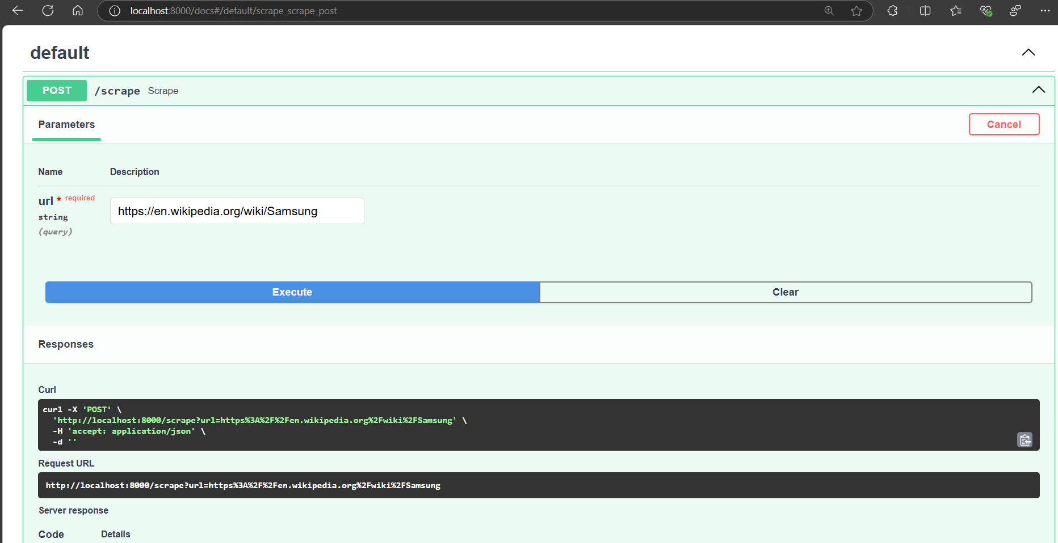

This screenshot displays the list of input URLs that were targeted for scraping. Each URL indicates a specific webpage from which content will be extracted. The message "successfully scraped" confirms that the content from these URLs was retrieved without any issues. This is a crucial step in ensuring that the data collection process is working as intended.

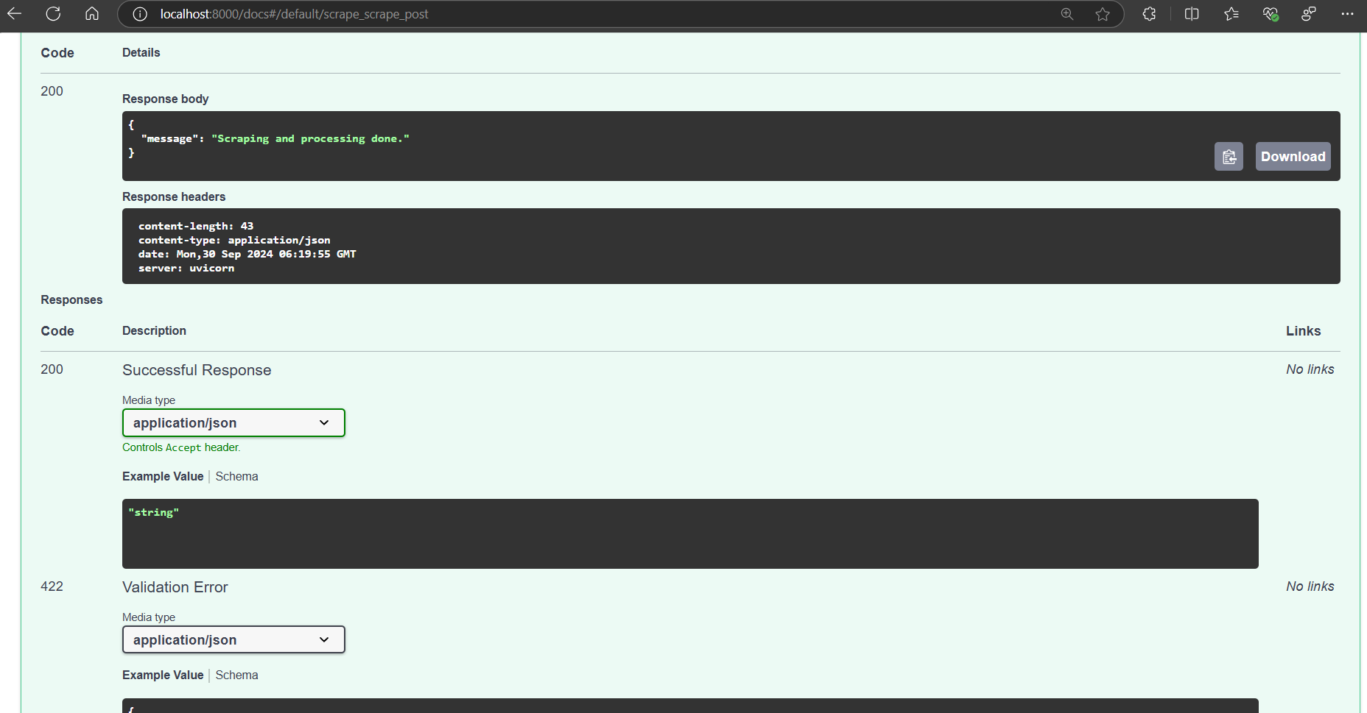

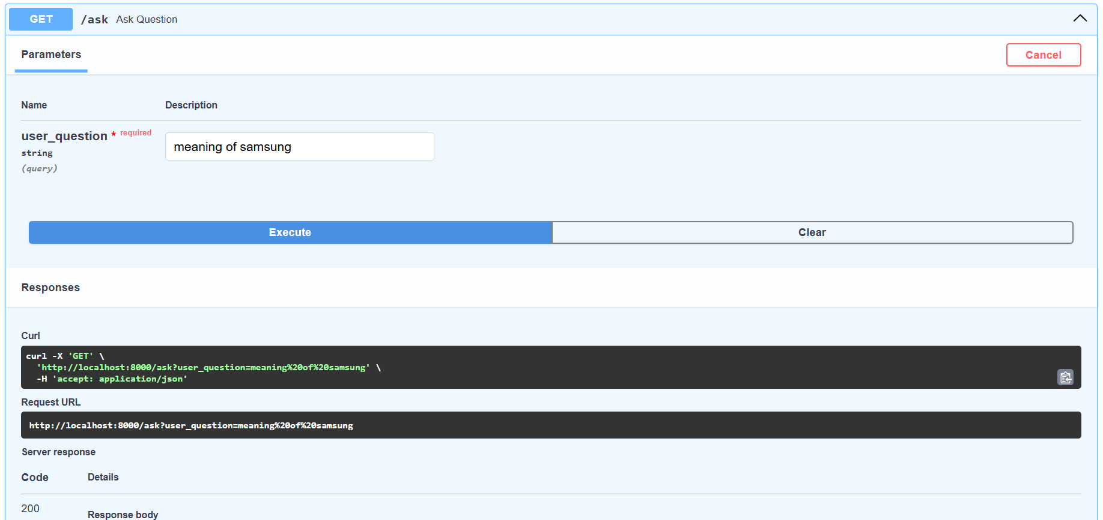

In this screenshot, the system is demonstrating its capability to process a query against the scraped content. By entering a specific question related to the information gathered, the application can intelligently analyze the content and provide a relevant answer

